**TEST MAJOO**

**(FULLSTACK)**

**-- Dokumentasi --**

**RIANIRSYAH DIAN NUGRAHANTO**

13 JAN – 15 JAN, 2022

1. **Entity Relationship Diagram (ERD)**

* Admin memanajen banyak produk (1 to many relationship)
* Produk memiliki produk kategori (many to one relationship)

1. **Data Manipulation Language (DML)**
   1. **Produk**

* **Select**

http://localhost/majoo/api/product

* **Insert**

http://localhost/majoo/api/product/add

* 1. **Category**
* **Select**

http://localhost/majoo/api/category

* **Insert**

http://localhost/majoo/api/category/add



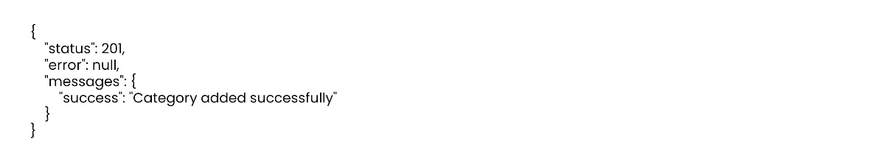

* **Update**

http://localhost/majoo/api/category/update/1



* **Delete**

http://localhost/majoo/api/category/delete/26

1. **Activity Diagram**

* **Pegawai Login**

* **Pegawai lihat tabel produk**

* **Pegawai tambah produk**

* **Pegawai lihat tabel category**

* **Pegawai tambah category**

* **Pegawai edit data category**

* **Pegawai hapus data category**

1. **Use Case Diagram**

RIANIRSYAH DIAN NUGRAHANTO

rianirsyahnugrahanto@gmail.com

082257883916